CONFIDENTIAL
Inst. Sc.
REQUIREMENTS
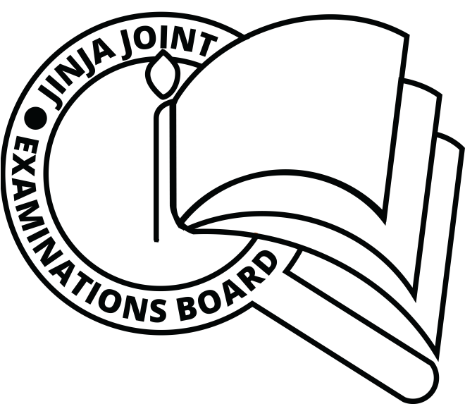
FOR IPS ART
Papers 612, 2/3/5/6
AUGUST, 2019

JINJA JOINT EXAMINATIONS BOARD

Uganda Certificate of Education

MOCK EXAMINATIONS –AUGUST, 2019

IPS 612 ART

Paper 2,3,5,6. Instructions

Great care should be taken so that the information given below does not
Reach the candidates either directly or indirectly.
INSTRUCTIONS FOR PREPARING THE ITEMS:
The Head teacher should make sure that the teacher responsible for preparing
the items, gets all items ready before the examination.

LIST OF ITEMS
The following items should be made available for setting not more than two hours to the sitting of the paper on the day of examination.

NB; This information is meant to be used by the subject teacher in preparing the items. No item should be substituted under any circumstance.

612/2 JJEB 2019 INSTRUCTIONS
CONFIDENTIALS
- A Scrubbing Brush 25cm long
- A 10 liter jerican
- 1 or 1½ Magic/Nomi /Omo tin
- A Bar of washing soap
- A pair of new bathroom slippers
- A pair of Gumboots
- A plastic basin
- A hand woven basket (Ekiibbo) 45 cm diameter
- 4 cassava tubers approximately 35-40 cm length
- 10 ovacardos
- 2 big size fresh maize cobs with covers
- 1 heap of red round tomatoes
- A new knife
- A ready pawpaw 25 cm long (approximately)
- A grasshopper with its wings

612/3 JJEB 2019 INSTRUCTIONS
CONFIDENTIALS
- A youthful model
- A pair of sports wears (short sleeved)
- Short sleeved shirt
- An office chair
- An office table

612/5 JJEB 2019 INSTRUCTIONS
CONFIDENTIALS
- Full mathematical set
- A long ruler
- Tracing paper
- Letraset
- Paper approx 35 cm x50 cm
- Colours (poster cclours, crayons, coloured pencils, pastels, compo pens) etc
- Drawing board/table

612/6 (CRAFT B STUDIO TECHNOLOGY)
JJEB 2019 INSTRUCTIONS
CONFIDENTIAL PAPER (Materials)
- ¼ metre piece of Nytil fabric
- Printing paste (different colours)
- Soap (approximately 8 cm for each candidate)
- Cutters
- Stencils
- Root tuber
- Meter ruler
- Cereals
- Sisal/ yarns
- Glue
- Hard cardboard (approx 30 cm x 20 cm)

